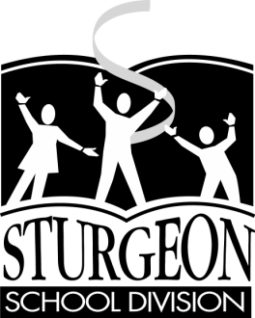
Box 200
Namao, AB T0A 2N0
780-973-9191

COURSE OUTLINE

Science 8

SEPTEMBER 2014 – JUNE 2015

Ms. Shute
jshute@sturgeon.ab.ca

Student Signature:

Parent Signature:

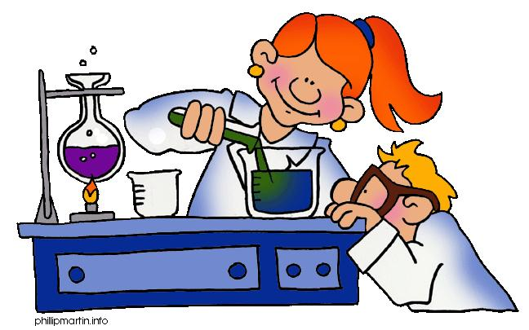

Science 8 – 2014/2015

OBJECTIVES

To develop in students a scientific literacy through:
  - Understanding of basic scientific concepts and development of skills
  - Applying of such concepts and skills
  - Communicating scientific ideals effectively
  - Developing critical and creative thinking skills

Understanding how science can be used to explain or solve natural or real – life situations

COURSE OUTLINE

UNIT A – Mix and Flow of Matter
- Students will investigate and describe fluids used in technological devices and everyday materials.
- Students will investigate and describe the composition of fluids, and interpret the behaviour of materials in solution.
- Students will investigate and compare the properties of gases and liquids; and relate variations in their viscosity, density, buoyancy and compressibility to the particle model of matter
- Identify, interpret and apply technologies based on properties of fluids.

Unit B: Cells and Systems (Nature of Science Emphasis)

- Students will investigate living things; and identify and apply scientific ideas used to interpret their general structure, function and organization.
- Students will investigate and describe the role of cells within living things.
- Students will interpret the healthy function of human body systems, and illustrate ways the body reacts to internal and external stimuli.
- Students will describe areas of scientific investigation leading to new knowledge about body systems and to new medical applications.

Unit C: Light and Optical Systems (Nature of Science Emphasis)

- Students will investigate the nature of light and vision; and describe the role of invention, explanation and inquiry in developing our current knowledge.
- Students will investigate the transmission of light, and describe its behaviour using a geometric ray model.
- Students will investigate and explain the science of image formation and vision, and interpret related technologies.

Unit D: Mechanical Systems (Science and Technology Emphasis)

- Students will illustrate the development of science and technology by describing, comparing and interpreting mechanical devices that have been improved over time.
- Students will analyze machines by describing the structures and functions of the overall system, the subsystems and the component parts.
- Students will analyze machines by describing the structures and functions of the overall system, the subsystems and the component parts.
- Students will analyze the social and environmental contexts of science and technology, as they apply to the development of mechanical devices.

Unit E: Freshwater and Saltwater Systems (Social and Environmental Emphasis)

- Students will describe the distribution and characteristics of water in local and global environments, and identify.
- Students will investigate and interpret linkages among landforms, water and climate.
- Students will analyze factors affecting productivity and species distribution in marine and freshwater environments.
- Students analyze human impacts on aquatic systems; and identify the roles of science and technology in addressing related questions, problems and issues.

COURSE SET UP

Journal/Portfolio  Assignments, Projects, & Labs | 45%
Quizzes  Exams | 40%
Final Exam | 15%

- REQUIRED MATERIALS

- Textbook
- Binder with Paper
- Portfolio, (Duotang(s) that will be kept in the classroom)
- Pen (s) & Pencil(s)
- Pencil Crayons, Felts, Crayons (One type is sufficient)
- Ruler
- Eraser
- Graph paper
- Scientific calculator

EXPECTATIONS
- Students need to attend every class and complete assigned work.
- Students, who do not complete assigned work, will be expected to attend a detention to complete the work.
- Students need to inform the office if they are away during an exam or quiz.
- ASSESSMENT RE – WRITE POLICY

- Students will not be permitted to re – write tests, (unit exams).
- Students will only be permitted to re – write assignments and quizzes at the discretion of the teacher.

- NHI – NOT HANDED IN POLICY
- If an assignment is not completed to the instructor’s satisfaction it will be awarded an NHI, (Not Handed In). A student will be given opportunities to turn this assignment in at a later date as long as the conditions outlined in the assessment re – write policy, (section F) are met. The student will be allowed these opportunities until completion of the unit the assignment is included in. Upon the completion of the unit, (a unit test has been taken), the mark will remain an NHI, (weighted as a zero), for the remainder of the school year.

*** Exceptions to the expectations, re – write policy and NHI policy may occur, are rare, and are at the discretion of the teacher. ***

