Math 8: Surface Area Final Exam Review
- Views of 3D Objects
- Draw and label the top, front and side view of the object. Use a ruler!

- Sketch a 3D object. Use isometric dot paper!
Top Front Side

- Draw the top, front and side view after a 90˚ clockwise rotation.

- Nets of 3D objects.
- Sketch a net for the object.
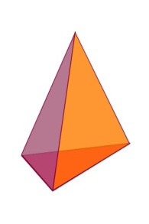
- Identify the solid that can be created by the net. Provide a sketch.
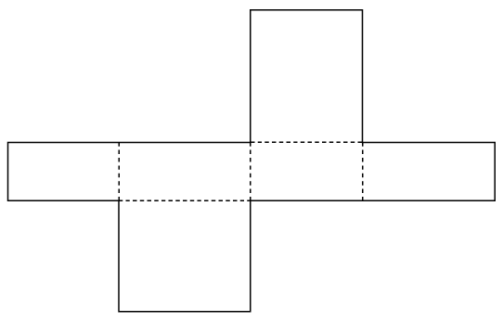

- Surface Area of a Prism
- Find the surface area to the nearest tenth.

- Jill is covering three blocks with paper. The dimensions of the first box are 1 cm x 1 cm x 1cm, the second are 2 cm x 2cm x 2cm and the third is 3 cm x 3cm x 3cm. If he is not covering the tops how much paper does she need?

- Surface Area of a Cylinder
- Find the surface area of a cylinder to the nearest tenth with a diameter of 10 cm and length of 72 cm.
- If the following cylinder needs to painted with one coat everywhere except the bottom, how much paint is required?

Questions to Review
Page 168 #3 – 7, 9
Page 173 #3 – 5, 7, 8
5.1 & 5.2 Views of 3D Objects & Nets of 3D Objects (This was an assignment “for marks”)
Page 180 # 3, 5, 6, 7, 8, 10, 11, 12 (I would look at these!!!)
Page 186 # 5, 6, 8 – 10
Surface Area Assignment 2
Surface Area Test

